GENERAL CHEMISTRY II
CHEM 1412.004 (23305)
SPRING 2015

PALO ALTO COLLEGE
LABORATORY COURSE SYLLABUS

Class Meeting
Times: Wednesdays, 1:00 pm – 3:30 pm in San Jacinto Hall, 209

Instructor: Mr. Dale L. Robinson

Phone: 210-486-3375

E-Mail: drobinson@alamo.edu

Prerequisites: Credit for CHEM 1111 or CHEM 1411 with a grade of “C” or better.

Course
Description: Basic laboratory experiments supporting theoretical principles presented in lecture; introduction of the scientific method, experimental design, chemical instrumentation, data collection and analysis, and preparation of laboratory reports.

Text: Beran, Jo A., Laboratory Manual for Principles of General Chemistry, Tenth Ed., John Wiley & Sons, ©2014. ISBN : 978-1-118-62151-6
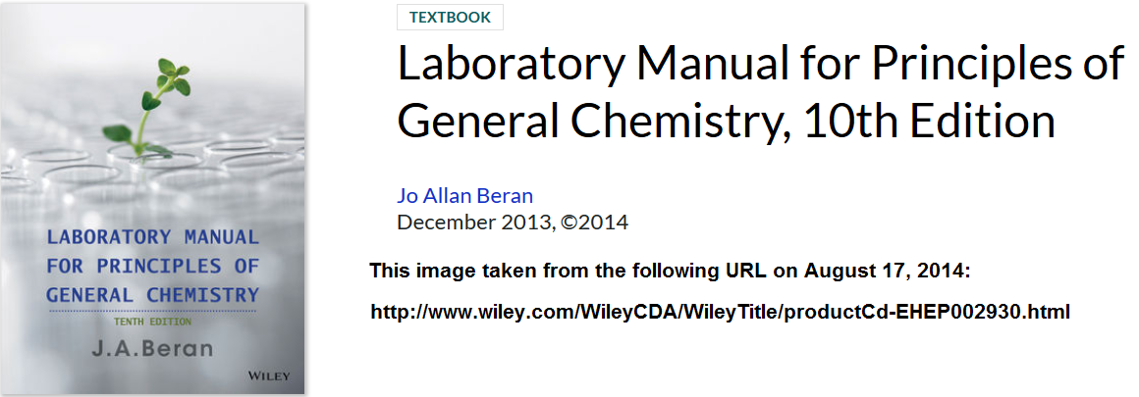

Learning Outcomes

Upon successful completion of this course, students will:

1. Use basic apparatus and apply experimental methodologies used in the chemistry laboratory.
2. Demonstrate safe and proper handling of laboratory equipment and chemicals.
3. Conduct basic laboratory experiments with proper laboratory techniques.
4. Make careful and accurate experimental observations.
5. Relate physical observations and measurements to theoretical principles.
6. Interpret laboratory results and experimental data, and reach logical conclusions.
7. Record experimental work completely and accurately in laboratory notebooks and communicate experimental results clearly in written reports.
8. Design fundamental experiments involving principles of chemistry and chemical instrumentation.
9. Identify appropriate sources of information for conducting laboratory experiments involving principles of chemistry.

Grading: Laboratory Reports (drop lowest) 40%
Laboratory Quizzes (drop lowest) 40%
Formal Report 20%
___________________________________________
Total 100%

Your Laboratory Semester Score (LSS) will be computed using the following formula, which incorporates the percentages given in the above table. Denoting your lab report average as LRA, your lab quiz average LQA, and the grade on your formal report as FR, your Laboratory Semester Score (LSS) is calculated as follows:.

LSS = 0.40 * LRA + 0.40 * LQA + 0.20 * FR

This score will count 25% toward your CHEM 1412 course grade, with the remaining 75% coming from the lecture part of the course.

Attendance Policy: Prompt and regular attendance is required. Students missing two (2) labs (not necessarily consecutive) may be withdrawn from the course (both lecture and lab) by the instructor. Students are responsible for all work missed due to any absences. In particular, note that students are not exempt from a lab quiz that covers an experiment conducted while they were absent. It is the students’ responsibility to determine what they missed while absent, and to familiarize themselves with the procedures of and principles behind the experiments conducted in their absence.

Student
Withdrawal Policy: Students wishing to withdraw from the course should file the proper paperwork with the Admissions and Records Office. If a student stops attending but does not formally withdraw, a grade of F will be assigned if the student is still “enrolled” at the end of the semester. This is true even if the student could have been dropped by the instructor under the attendance policy above.
Notes on
Lab Reports: For each week that lab meets (except for the first meeting), a laboratory experiment will be conducted. For each experiment conducted, there is a Lab Report that must be completed. Lab Reports usually have three (3) parts. First, there is a Lab Preview which should be completed before beginning the experiment. Secondly, there is a Data Sheet on which the measurements and observations made during the experiment are recorded. Finally, there is a set of post lab Questions which test your understanding of the principles behind the experiment. In general, students will work as a group (not to exceed 4 students unless the instructor approves otherwise) on completing the lab report, but the instructor has the option of requiring that part or all of any lab report be an individual effort. Unless you are told otherwise, however, you may work together on completing your lab report for an experiment, and only one report will be turned in for each group of students working on an experiment. The grade earned on the lab report is assigned to all students working in the group. However, the instructor may make adjustments to an individual student’s grade where appropriate, to account for significant differences in participation or adherence to laboratory rules.

Members of a group who are absent for a particular experiment are not eligible to receive a grade for the experiment which the other group members completed in their absence. Active participation in an experiment is required for a student to receive a grade for that experiment.

After the physical work of the experiment has been completed, each group is expected to clean up their work area and spend the remainder of the lab period finishing the Group Lab Report. If the remaining time is not sufficient to finish the Group Lab Report, a one-time extension will be granted at the end of the lab period, making it possible for the group to turn in the Group Lab Report at the beginning of the next lab meeting without a late penalty. If a group leaves the lab before the end of the period without submitting a Group Lab Report, the report is considered late. Late lab reports carry a 20% grade penalty. After the lab reports for a particular experiment have been graded and returned to the students, late lab reports for that experiment can no longer be accepted.

If a group member arrives late or leaves the lab early, the lab instructor may determine an appropriate reduction in lab report grade for that student, to account for his or her diminished participation in the experiment. A student who must leave the lab early should notify the instructor when they leave. If a student quietly “slips out” without notice, the instructor may count the student as absent for the entire lab and assign zero credit for that experiment.
Notes on
Lab Quizzes: Lab Quizzes covering the experiments that students have conducted will be given from time to time. The quiz dates and the number of quizzes to be given have not been determined in advance. Lab quizzes will be announced in lab the week before they are to be given. Your lowest lab quiz grade is dropped before computing your lab quiz average. In consideration of this privilege, and the time required to prepare and grade make-up assignments, students are not allowed to make up just one missed lab quiz. If more than one quiz is missed, and all were missed for valid reasons, see the instructor. Such situations are handled on a case-by-case basis.

Notes on the
Formal Report: The formal report is a typewritten (or computer printed) paper that discusses one of the experiments conducted during the semester. The report must contain the following seven (7) sections: Abstract, Introduction, Procedure, Results, Discussion, Conclusion, and References. More details on the paper – including when it will be due – will be provided at a later date.

Laboratory Safety: Students are required to practice safe laboratory techniques at all times. This includes (but is not limited to) wearing safety glasses whenever experiments are in progress. Even when an individual student is just doing paperwork, that student must be wearing safety glasses if experimental procedures are in progress elsewhere in the lab. A grade penalty may be imposed for failure to adhere to required safety rules.

A student who arrives for lab without safety glasses and for whom safety glasses cannot be found will not be allowed to conduct that day’s experiment and will be considered absent for the day.

Make-up Work: The experiments in this course are only available during their scheduled week. If you miss an experiment, you will not be able to conduct that experiment at a later time. However, one lab report grade will be dropped before your lab report average is calculated, and that will be the only way to handle a missed lab. That is, your grade for the missed lab will be zero, but that zero will be dropped and not used in the calculation of your lab report average. If you miss more than one lab, the additional grades of zero will be used in the calculation of your lab report average, since only one lab report grade can be dropped. Note, however, that you may be withdrawn from the course if you miss two or more labs. Since the laboratory course is embedded in the lecture course, being withdrawn from the laboratory course also means being withdrawn from the lecture course.

If you are absent from lab on the day a lab quiz is given, your grade for that quiz will be zero, but will be eligible to be dropped before calculation of the lab quiz average, unless that privilege has already been used. Missing more than one lab quiz will result in grades of zero (after the first such grade) being incorporated into your lab quiz average, since only one lab quiz grade can be dropped.

The first missed lab quiz cannot be made up. If more than one lab quiz is missed, and all were missed for valid reasons, contact the instructor. Such situations are handled on a case-by-case basis. Note, however, that missing 2 or more labs puts you at risk of being withdrawn from the course.

GENERAL CHEMISTRY II
LABORATORY SCHEDULE
CHEM 1412.004 (23305)
SPRING 2015

January 21 Introduction. No experiment today.

January 28 Experiment 3: “Water Analysis: Solids”

February 4 Experiment 21: “Hard Water Analysis”

February 11 Experiment 35: “Spectrophotometric Metal Ion Analysis”

February 18 Experiment 14: “Molar Mass of a Solid”

February 25 Experiment 23: “Factors Affecting Reaction Rates”

March 4 Experiment 24: “A Rate Law and Activation Energy”

March 11 SPRING BREAK

March 18 Experiment 16: “Le Chatelier’s Principle; Buffers”

March 25 Experiment 17: “Antacid Analysis”

April 1 Experiment 34: “An Equilibrium Constant”

April 8 Experiment 22: “Molar Solubility; Common Ion Effect”

April 15 Experiment 37: “Qual: Common Anions”

April 22 Experiment 38: “Qual I. Na⁺, K⁺, NH₄⁺, Mg²⁺, Ca²⁺, Cu²⁺”

April 29 Experiment 39: “Qual II. Ni²⁺, Fe³⁺, Al³⁺, Zn²⁺”

May 6 No Lab Meeting. Course is finished.

Academic Calendar for the Spring 2015 (16-week) Semester

Date Day of Week Event

January 5 Monday College opens

January 12 Monday Faculty Report

January 19 Monday Martin Luther King Day – College closed

January 20 Tuesday Classes begin

January 24 Saturday Weekend classes begin

February 4 Wednesday Census date.

March 9 – 15 Monday - Sunday Spring Break – College Closed
April 3 – 5 Friday - Sunday Easter Holiday – College closed

April 17 Friday Last day to withdraw

April 24 Friday Fiesta Holiday – College closed
Weekend classes will meet

May 8 Friday Last day of classes

May 11 – 16 Monday - Saturday Final Examinations

May 16 Saturday End of Spring 2015 Semester

September 14, 2015 Monday Last day for Incomplete (“I”) grades to be completed

